

COLLEGE OF COMPUTER STUDIES

CCS007L (COMPUTER PROGRAMMING 2)

EXERCISE

7 FILE HANDLING

Student Name / Group Name:
Jed L. Hizon
Name Role

Members (if Group):

AN11 – Term 2
Section:

Professor:
Mr. Cezar

I. PROGRAM OUTCOME/S (PO) ADDRESSED BY THE LABORATORY EXERCISE

• Design, implement and evaluate computer-based systems or applications to meet desired needs and requirements. [PO: C]

II. COURSE LEARNING OUTCOME/S (CLO)ADDRESSED BY THE LABORATORY EXERCISE

• Apply the fundamental principles of handling CString values, pointers and memory

allocation, and structures using C++in solving computing activities [CLO: 2]

III. INTENDED LEARNING OUTCOME/S (ILO) OF THE LABORATORY EXERCISE At

the end of this exercise, students must be able to:

• Create a program that open a given text file, process, and write the output to another file.
• Create a record management system that stores basic information on a given text file and load the data when opened.

IV. BACKGROUND INFORMATION

To perform file processing in C++, header files <iostream> and <fstream> must be included in your C++ source file.

ThisrequiresanotherstandardC++ library calledfstream, whichdefinesthreenewdata types:

Data Type

ofstream

ifstream

fstream
Description

This data type represents the output file stream and is used to create files and to write information to files.

This data type represents the input file stream and is used to read information from files.

This data type represents the file stream generally, and has the capabilities of both ofstream and ifstream which means it can create files, write information to files, and read information from files.

CCS007L-Computer Programming 2 Page 2 of 10
V. GRADING SYSTEM / RUBRIC

Trait

Requirement Specification(30pts)

Data type(20pts)

Input Validation(20pts)

Free from syntax, logic, and runtime errors (10pts)

Delivery (10pts)

Use of Comments (10pts)
(Excellent)
Able to identify correctly all input and output and provide alternative. (28-20pts)

Able to apply required data type or data structure and produce correct results (1820pts)

The program works and meets all specifications. Does exception al checking for errors and out-of- range data (18-20pts)
Unable to run program (10pts)

The program was delivered on time (10pts)

Specific purpose is noted for each function, control structure, input requirements, and output results. (10pts)
(Good)
Able to identify correctly all input and output (25-17pts)

Able to apply required data type or data structure and produce partially correct results (15-17pts)
The program works and meets all specifications. Does some checking for errors and out of range data (15-17pts)

Able to run program but have logic error (8-9pts)

The program was delivered after 5 minutes from the time required. (89pts)

Specific purpose is noted for each function and control structure. (8-9pts)
(Fair)
Able to identify only one input or output (22-14pts)

Able to identify required data type or data structure but does apply correctly (12-14pts)

The program produces correct results but does not display correctly Does not check for errors and out of range data
(12-14pts)

Able to run program correctly without any logic error and display inappropriate output (6-7pts)

The program was delivered after 10 minutes from the time required. (67pts)

Purpose is noted for each function. (67pts)
(Poor)
Unable to identify any input and output (20-11pts)

Unable to identify required data type (9-11pts)

The program produce s incorrect results (9-11pts)

Able to run program correctly without any logic error and display appropriate output (5pts)

The program was delivered after 15 (or more) minutes from the time required. (5pts)
No comments included. (5pts)

CCS007L-Computer Programming 2 Page 3 of 10
VI. LABORATORY ACTIVITY

INSTRUCTIONS:
Copy your source codes to be pasted in this document as well as a screen shot of your running output.
ACTIVITY 7.1: Player’s record with file operations
Redo your program in Laboratory Activity 6, this time you have to save the records to a text file and will be retrieved for display. Your program must be able to keep records and compute for the scores of 5 players. The information of each player contains: Nickname, Age and two best played scores.

The program will prompt the user to choose the operation of records from a menu as shown below:

============================================== MENU
==============================================

1. Add record
2. View players records
3. Compute for the average
4. Show the player(s) who gets the max average. 5. Show the player(s) who gets the min average. 6. Open the file.
7. Close the File 8. Exit

Follow the following steps to help you complete the task 1. Declare the header files

#include <iostream> #include <fstream> #include <string>

using namespace std;

CCS007L-Computer Programming 2 Page 4 of 10
2. Create a Player and Node structure

struct Player { string nickname; int age;
double scores[5]; };

struct Node { Player player; Node* next;
};

3. Set head of the linked list

Node* head = nullptr;

4. Let’s create a Function to add a player record to the linked list

void addRecord(const Player& player) { Node* newNode = new Node; newNode->player = player; newNode->next = head;
head = newNode; }

CCS007L-Computer Programming 2 Page 5 of 10
5. Let’s create a Function to view player records

void viewRecords() { Node* current = head;
while (current != nullptr) {
cout << "Nickname: " << current->player.nickname << endl; cout << "Age: " << current->player.age << endl;
cout << "Scores: ";
for (int i = 0; i < 5; ++i) {
cout << current->player.scores[i] << " "; }
cout << endl;
cout << "----------------------------------" << endl; current = current->next;
} }

6. The function to compute the average of scores

void computeAverage() { Node* current = head; while (current != nullptr) {
double sum = 0;
for (int i = 0; i < 5; ++i) {
sum += current->player.scores[i]; }
double average = sum / 5.0;
cout << "Nickname: " << current->player.nickname << endl; cout << "Average Score: " << average << endl;
cout << "----------------------------------" << endl; current = current->next;
} }

CCS007L-Computer Programming 2 Page 6 of 10
7. Here’s the function of geting the maximum average score

void showMaxAverage() { Node* current = head;
double maxAverage = -1; // Initialize to a non-valid value while (current != nullptr) {
double sum = 0;
for (int i = 0; i < 5; ++i) {
sum += current->player.scores[i]; }
double average = sum / 5.0; if (average > maxAverage) {
maxAverage = average; }
current = current->next; }
// Now, iterate again to display players with the max average current = head;
while (current != nullptr) { double sum = 0;
for (int i = 0; i < 5; ++i) {
sum += current->player.scores[i]; }
double average = sum / 5.0; if (average == maxAverage) {
cout << "Nickname: " << current->player.nickname << endl; cout << "Average Score: " << average << endl;
cout << "----------------------------------" << endl; }
current = current->next; }
}

CCS007L-Computer Programming 2 Page 7 of 10
8. Here’s the function for geting the minimum average

void showMinAverage() { Node* current = head;
double minAverage = 100; // Initialize to a value higher than the possible average while (current != nullptr) {
double sum = 0;
for (int i = 0; i < 5; ++i) {
sum += current->player.scores[i]; }
double average = sum / 5.0; if (average < minAverage) {
minAverage = average; }
current = current->next; }
// Now, iterate again to display players with the min average current = head;
while (current != nullptr) { double sum = 0;
for (int i = 0; i < 5; ++i) {
sum += current->player.scores[i]; }
double average = sum / 5.0; if (average == minAverage) {
cout << "Nickname: " << current->player.nickname << endl; cout << "Average Score: " << average << endl;
cout << "----------------------------------" << endl; }
current = current->next; }
}

CCS007L-Computer Programming 2 Page 8 of 10
9. Now we need an open and close function

void openFile() {
ofstream outFile("player_records.txt"); Node* current = head;
while (current != nullptr) {
outFile << current->player.nickname << endl; outFile << current->player.age << endl;
for (int i = 0; i < 5; ++i) {
outFile << current->player.scores[i] << " "; }
outFile << endl;
current = current->next; }
outFile.close();
cout << "Records saved to 'player_records.txt'." << endl; }

// Function to indicate closing the file void closeFile() {
cout << "File closed." << endl; }

10. Complete the program by adding the main function creating a menu. Use looping and switch statements for the main function.

11. Submit the file and output screenshots of your program here:

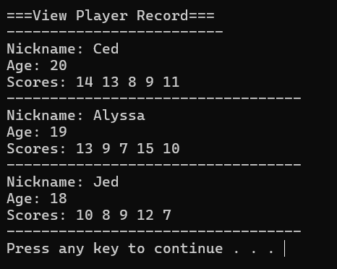
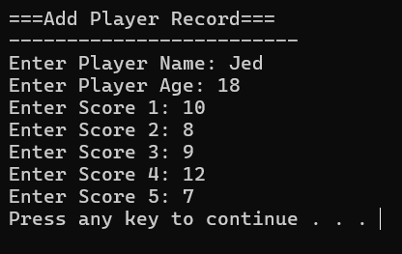
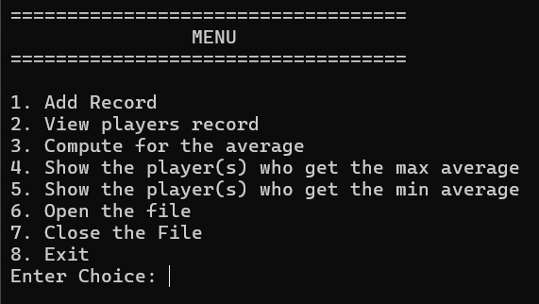
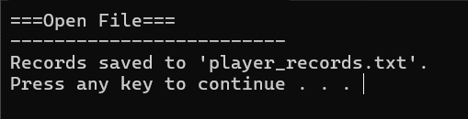
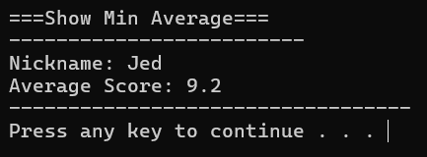
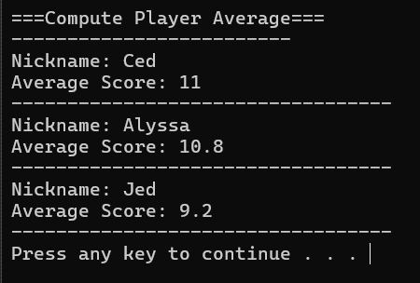
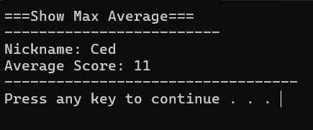
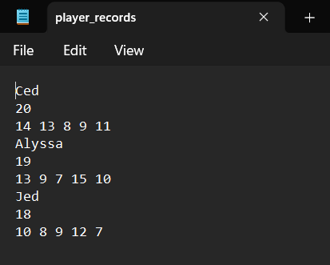

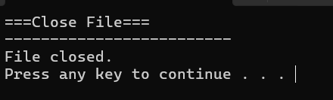

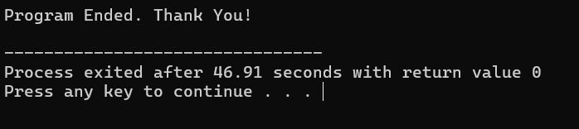

CCS007L-Computer Programming 2 Page 9 of 10

VII. QUESTION AND ANSWER

Briefly answer the questions below. Avoid erasures. For group activity, specify the name of GROUP MEMBER/s who answered the question. Do not forget to include the source for all NON-ORIGINAL IDEAS.

• What C++ header file libraries are used in file handling?
The primary header file library used in C++ for file handling is <fstream>.

• What are file modes? Discuss each mode.

Modes | Descriptions
in | Opens the file to read(default for ifstream)
out | Opens the file to write(default for ofstream)
binary | Opens the file in binary mode
app | Opens the file and appends all the outputs at the end
ate | Opens the file and moves the control to the end of the file
trunc | Removes the data in the existing file
nocreate | Opens the file only if it already exists
noreplace | Opens the file only if it does not already exist

https://www.edureka.co/blog/file-handling-in-cpp/

CCS007L-Computer Programming 2 Page 10 of 10

